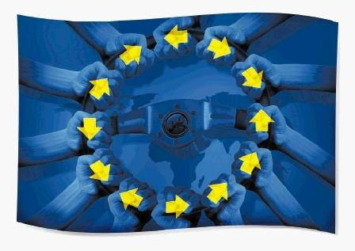**Endangered Environment:**

**How EU funds are subsidising environmental destruction**

As EU member states tackle the environmental agenda, the EU spending machine rolls on. More than €350 billion has been allocated over 7 years in structural funds alone and €100s of billions in European Investment Bank (EIB) loans being dished out, taxpayer’s money is being pushed into green projects.

With aims for 20% reductions in Co2 emissions by 2020, an expanding network of protected areas and generous subsidies for renewable energy projects, the green agenda looks as if it’s going in the right direction.

But up to now this spending has gone unchecked. The funds cover a vast area - 27 countries, 169 Regions, 23 languages and 500,000 projects - even Brussels doesn’t know who gets it. Nobody has tracked where the money is spent and whether it is all worth it.

While the EU will head up the UN Convention on Climate Change in sunny Cancun on the 29th of November, we can reveal that the EU continues to subsidise environmentally destructive projects.

In collaboration with The Financial Times, the Bureau of Investigative Journalism has collected hundreds of thousand files on how the EU spends its money. Our files have allowed us to pinpoint where the funds are going and on the way we have uncovered a trail of waste, destruction and corruption affecting the environment and EU citizens in every member state.

The results are striking:

**Energy EU:** With the drive towards cutting CO2 emissions by 20% by 2020 the EU is putting its money where its mouth is. The move has lead to the development of some questionable projects; Nuclear power plants on earthquake fault lines and incinerators spewing out cancer causing dioxins. It seems the promise of subsidies is too great and EU funds are promoting the lure of quick profit over the environment. Meanwhile solar panel production is being stepped up, using toxic carcinogenic chemicals and the endangered species list has been adjusted to allow for wind farms to be built in protected areas.

**Toxic waste:** EU funded projects are failing to deal properly with waste. The power of the Italian eco mafia has a firm grip on the south of Italy and they have managed to cash in on green EU money. Landfill and waste sites, funded by the taxpayer, are being run by gangsters, creating toxic waste and have caused rocketing levels of dioxins and are believed to have caused abnormal cancer rates in affected populations. Plans are ahead for incinerators near population centres, driving down recycling rates. Other forms of mismanagement have seen landfill effluent seeping into underground aquifers.

**Projects that Harm:** We can uncover that EU funds have caused an explosion of unchecked development to the detriment of the environment. Buildings and landfill sites are being rolled out in EU designated Natura 2000 sites and UNESCO protected areas in violation of the rules designed to preserve them. Millions of taxpayer’s Euros are going towards constructing luxury hotels, ski resorts, golf courses, motorways, piers and unplanned wind farms all in protected areas.

ENERGY EU

With the drive to cut CO2 emissions by 20% by 2020 the EU has started to pump resources into funding to renewable energy sources. At least €5bn will go to EU energy projects from structural funds between 2007-2013, while €100s of billions in loans will be given out by the EIB. The results of this mass spending are shocking.

**Incinerators; Burning Europe’s bridges to a greener future**

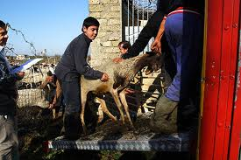While the EU is driving the green agenda, much of the waste management budget is being pushed into controversial incinerators and to add insult to injury, they will benefit from generous renewable energy subsidies.

EU funded waste disposal projects are creating havoc with the environment and residents. In Acerra, Southern Italy, official sources claim that they are facing an “*apocalyptic scenario”.* Years of mismanagement have caused dioxin levels in local residents and livestock to rocket, exceeding safe levels by a factor of 25, (close to the levels seen in Vietnam veterans from napalm exposure), causing premature deaths and high cancer rates in affected areas, documented by the WHO.

Hundreds of millions in EU structural funds went into building the Acerra incinerator and seven factories which manufactured the toxic waste. Senior officials involved are currently being prosecuted for not conducting a proper tender process, not having an environmental assessment report, and not having the minimum safety standards in both operations and emissions.

However the EU has continued to turn a blind eye to the issues raised by incinerators and the taxpayer continues to cover for the past failures of environmental projects. Today whilst Sicilian waste companies continue to receive EU funds to decommission their dysfunctional and toxic incineration plants, plans for more incineration plants are rolling out in Eastern Europe, driving down recycling rates.

Biofuels

The Commission is currently involved in two court cases due to their failure to disclose studies on the future of biofuels. The cases are being taken by a number of environment-driven policy groups, who claim that the documentation point to the fact that biofuels are not effective in reducing CO2 emissions.

Despite this fact €82m of structural funds are being spent on biofuels.

Nuclear

On the banks of the Danube, Bulgaria’s newest nuclear reactor is under construction. The reactor will be situated on the Bulgarian-Romanian border 16km from the site of a major earthquake that killed 120 people in 1979. The EIB have been involved in the financing of the project. The reactor is also being constructed within a Natura 2000 site. There has been much dispute over the Environmental Impact Assessment (EIA) carried out which is the basis for the planning application. We are awaiting a copy of the EIA to investigate this matter further.

Solar

The production of solar panels uses the banned substance cadmium. Cadmium is highly toxic, carcinogenic, mutagen meaning it can cause life-threatening diseases for present and future generations.

Cadmium is currently on the EU list of restricted substances, however its use is permitted in the production solar panels, if no other alternative is available. Today numerous other options to cadmium have been developed but we can prove that the EU continues to fund the use of cadmium in solar panels.

Wind

The remote Spanish island and UNESCO biosphere of El Hierro, is set to become Spain’s first island to be powered entirely by renewable energy. Behind the scenes, the deals have been fraught with nepotism, corruption and blatant disregard for the island’s protected environment. The politicians behind the deals have ensured that the windfarms go ahead by reclassifying protected land, adjusting the register of endangered species and granting contracts to their colleagues.

Now the island is littered with wind turbines, erected with no proper planning in a nature reserve, endangering wildlife and to the outrage of the island’s residents.

While this is the case in Spain we have further evidence to show that wide scale fraud is taking place in relation to wind farms in Italy in Sicily, Sardinia and Campania.

TOXIC WASTE

Southern Italy and the Triangle of Death

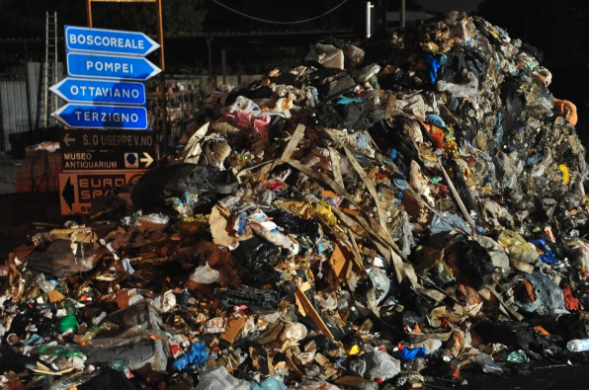The "waste wars" which have gripped southern Italy, have had knock on effects in the use of EU funding. In no place can this be better seen and understood than in Campania, where the waste crisis of 2008 has resulted in what has now become a military-lead operation to deal with Italy’s waste.   
  
While the streets of Naples appear to be trash and trouble free the development of what will be the EU’s biggest landfill site, at Vesuvius UNESCO biosphere, show the devastating effects of the waste wars. The community of Terzigno has become the latest victim in the struggles against the eco-mafia.

Despite the 1997 designated UNESCO status a landfill site was developed with EU funds in 2008 and went ahead despite opposition from the community, the EU Commission and the regional courts.   
  
The latest development in the saga has caused uproar amongst residents and the waste company Sapna have moved in to open a second landfill site. Over the past week there have been violent protests in the area. The army have been called in to escort the waste trucks following protests; the destruction of 46 vehicles and the burning of waste in the streets. Locals have descended on the town blocking off the landfill site and the local mayor Gennaro Langella has gone on a five-day hunger strike to make a stand against the development.

Langarella is not the only political figure who has taken a stand against the eco mafia. The major of Pollica, who was noted for his efforts against the power of the eco mafia, has been linked to the very people he opposed.

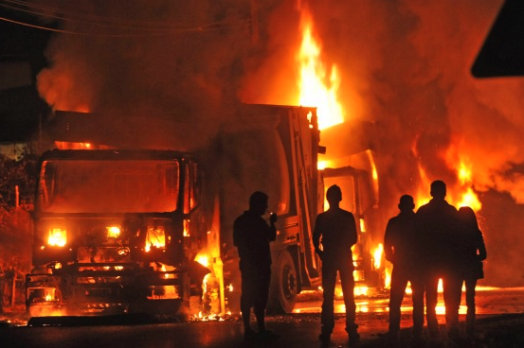Meanwhile companies like Italy’s Recam SPA, are being prosecuted for re-labeling (downgrading) toxic waste. They have then both incinerated it and mixed it with building materials causing untold environment damage in Southern Italy. Our database reveals that they continue to receive EU funding - €1.8 million from the current budget.

Why recycle when you can burn?

Former Soviet bloc countries like Poland and Lithuania tend to have recycling rates close to zero, but rather than tackling the problem, Europe’s taxpayers are now funding economically unviable and environmentally dubious projects.

Poland's recycling rates are currently the lowest in the EU, and are not set to improve. After intense lobbying by a German manufacturer, Remondis, 75% of its waste management budget (€1.6 billion) is now earmarked to building incinerators. Whilst the Polish must deal with their waste effectively, the German companies constructing the incinerators are reaping the financial benefits of the laws imposed on Poland.

With nine incinerators planned around residential areas, Polish residents are

increasingly concerned about their exposure to toxic emissions. Meanwhile in cities such as Bydgoszcz, recycling schemes have been axed with the announcement of the development of incinerators.

In Lithuania, Russian owned Gazprom are in line to receive 50% of the EU waste management budget for the development of two incinerators. Plans for these incinerators show them approximately 600m from housing.

**PROJECTS THAT HARM**

**Nature reserves**

The Natura 2000 network encompasses 20% of the EU. Designed to protect and conserve the biodiversity of the union’s most delicate environments, we can reveal that taxpayer’s money is being invested to the ruination of the EU countryside. Whilst €36m in EU funds have been earmarked for the Natura 2000 network, in other cases EU funds are going towards projects that actively harm the environment.

While the Commission has apologised for previous misuse and waste of taxpayer’s money on luxury hotels and golf clubs, we can reveal that they continue to receive hundreds of millions in EU funds.

Bulgaria

With Bulgaria’s accession to the EU a number of Natura 2000 eco-parks were introduced. The Bulgarian nature reserve of Kaliakra is one of them.

Kaliakra, on the Black Sea, is a place of outstanding beauty and a home to some of the most diverse wildlife in the EU. However in 2007 the boundaries of the reserve were adjusted - excluding some prime building sites from reserve. EU funded construction in the area soon followed. At present, 364 construction projects, most without Environmental Impact Assessments (EIA), have been granted planning permission.

Among these developments are EU funded wind farms and three luxury golf courses.

Spain

EU funds have helped pay for illegal hotels and unplanned developments in nature reserves. In O Porrino, €300,000 was spent on an unplanned development in a nature reserve. Today the building stands abandoned, dilapidated and covered in graffiti. What should have been a resource for the community, has become an eyesore due to corrupt building practices.

UNESCO attempted to preserve whole areas of Spain’s habitat when they declared them a biosphere This status is designed to encourage tourism, increase biodiversity and protect the environment by restricting development.

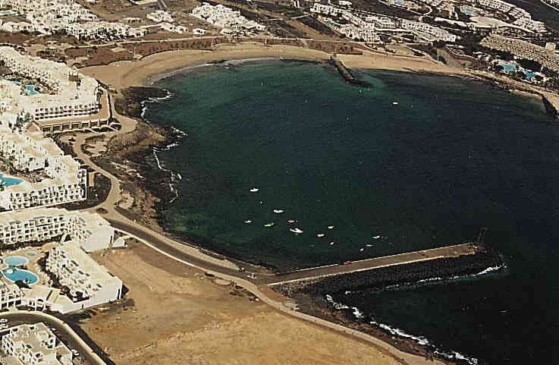Together with the Financial Times, the Bureau of Investigative Journalism have identified luxury hotels in Lanzarote that were allocated over €25m of EU subsidies. These hotels were built within a designated UNESCO biosphere. Developers used illegal planning permission granted by corrupt officials.

In the south of Spain the autovia A-48 will run from the Portugese border to the southern port city of Algeciras. However the majority of the road will run through an EU Natura 2000 reserve, endangering the local birdlife. Although numerous alternatives to the road have been proposed the planned route remains.

**The Bureau of Investigative Journalism**

**Approach**

This document is intended as the basis for further discussions

**Profile**

The Bureau of Investigative Journalism is a London based not-for-profit organisation that aims to produce original journalism by producing high-quality investigations for national and international press and broadcast media.

Since its launch in April 2010 it has already produced investigations for Channel 4 News, Aljazeera, and has commissions for the BBC’s flagship investigative journalism programme Panorama and Channel 4’s Dispatches.

Other investigations have already been published in the Financial Times, The Guardian, The Sunday Times and The Independent.

The bureau functions as a production house working in collaboration with other news groups to get its investigations published and distributed.

The Bureau has a team of over 20 award winning, multi-lingual producers, directors and journalists working across several major investigations, but at its core are editor Iain Overton and lead reporter Angus Stickler, a former BBC correspondent.

[www.thebureauinvestigates.com](http://www.thebureauinvestigates.com)